IOT Based Weather Application
Software Requirements Specification and Architecture
Version <1.0>

Revision History
Date | Version | Description | Author
<08/01/21> | <1.0> | SRS 1.0 | Shubhashree Bhattacharya

Table of Contents
1. Introduction 4
1.1 Purpose 4
1.2 Scope 4
1.3 Definitions, Acronyms, and Abbreviations 5
2. Overview of the product 5
3. Software Model 6
4. Software Implementation 7
5. System Requirements 7
5.1 Functionality 7
5.1.1 Central Control Plane 7
5.1.2 Provide comprehensive weather details. 8
5.1.3 Provide Search options. 8
5.1.4 Maintain customer profile. 8
5.1.5 Provide personalized profile 8
5.1.6 Provide detailed sitemap. 9
5.1.7 IOT Device. 9
5.1.8 Graphical User Interface 9
5.1.9 Accessibility 9
5.2 Reliability & Availability 9
5.2.1 Back-end Internal Computers 9
5.3 Performance 10
5.4 Security 10
5.4.1 Data Transfer 10
5.4.2 Data Storage 10
5.5 Supportability 10
5.5.1 Configuration Management Tool 10
5.6 Design Constraints 11
5.6.1 Standard Development Tools 11
5.6.2 Web Based Product 11
5.7 On-line User Documentation and Help System Requirements 11
5.8 Purchased Components 11
5.9 Interfaces 11
5.9.1 User Interfaces 11
5.9.2 Hardware Interfaces 12
5.9.3 Software Interfaces 12
5.9.4 Communications Interfaces 12
5.9.5 Licensing Requirements 12
5.9.6 Applicable Standards 12
6. Data Flow Diagram 12

Introduction

This project IoT-based weather application has been designed to facilitate the reporting of weather parameters over the Internet to a centralized place preferably in the cloud. In this, the IOT system will be embedded with temperature, humidity, and rain sensors that can monitor the weather conditions and provide live reports of weather statistics. Information will be stored in a centralized database; it will allow the users to directly check the weather statistics online without the need of a weather forecasting agency.

It will be an always-on, automated system that sends data via a microcontroller to the webserver using a WIFI or 5G connection. This data will be updated live on the online server system. So, anyone will be able directly check the weather statistics online without having to rely on the reports of weather forecasting agencies. The system will also allow to set threshold values and alerts for specific instances and will notify users every time the weather parameters cross the threshold value. Thus, this IOT based weather app will provide an efficient internet-based weather reporting system for users.

Purpose

The purpose of the document is to collect and analyze all assorted ideas that have come up to define the system, its requirements with respect to consumers. Also, we shall predict and sort out how we hope this product will be used to gain a better understanding of the project, outline concepts that may be developed later, and document ideas that are being considered, but may be discarded as the product develops.

In short, the purpose of this SRS document is to provide a detailed overview of our software product, its parameters, and goals. This document describes the project's target audience and its user interface, hardware, and software requirements. it helps any designer and developer to assist in software delivery lifecycle (SDLC) processes.

Scope

Primarily, the scope pertains to the development of an Internet of Things (IOT) based weather application. It focuses on the requirement gathering, system requirement specification, design, and implementation of the app.

This SRS is also aimed at specifying requirements of the software to be developed and its designed and implementation. The standard can be used to create software requirements specifications directly or can be used as a model for defining an organization or project specific standard. It does not identify any specific method, nomenclature, or tool for preparing an SRS.

Definitions, Acronyms, and Abbreviations

IOT | Internet of Things
UI | User Interface
API | Application Programming Interface

Overview of the product

This document provides a general description, including characteristics of the users of this project, the product's hardware, and the functional and data requirements of the system. It contains the proposed solution. It also illustrates the needs and wants of the application that were identified in the brainstorming exercise as part of the requirements workshop. It further lists and briefly describes the major features and a brief description of each of the proposed system.

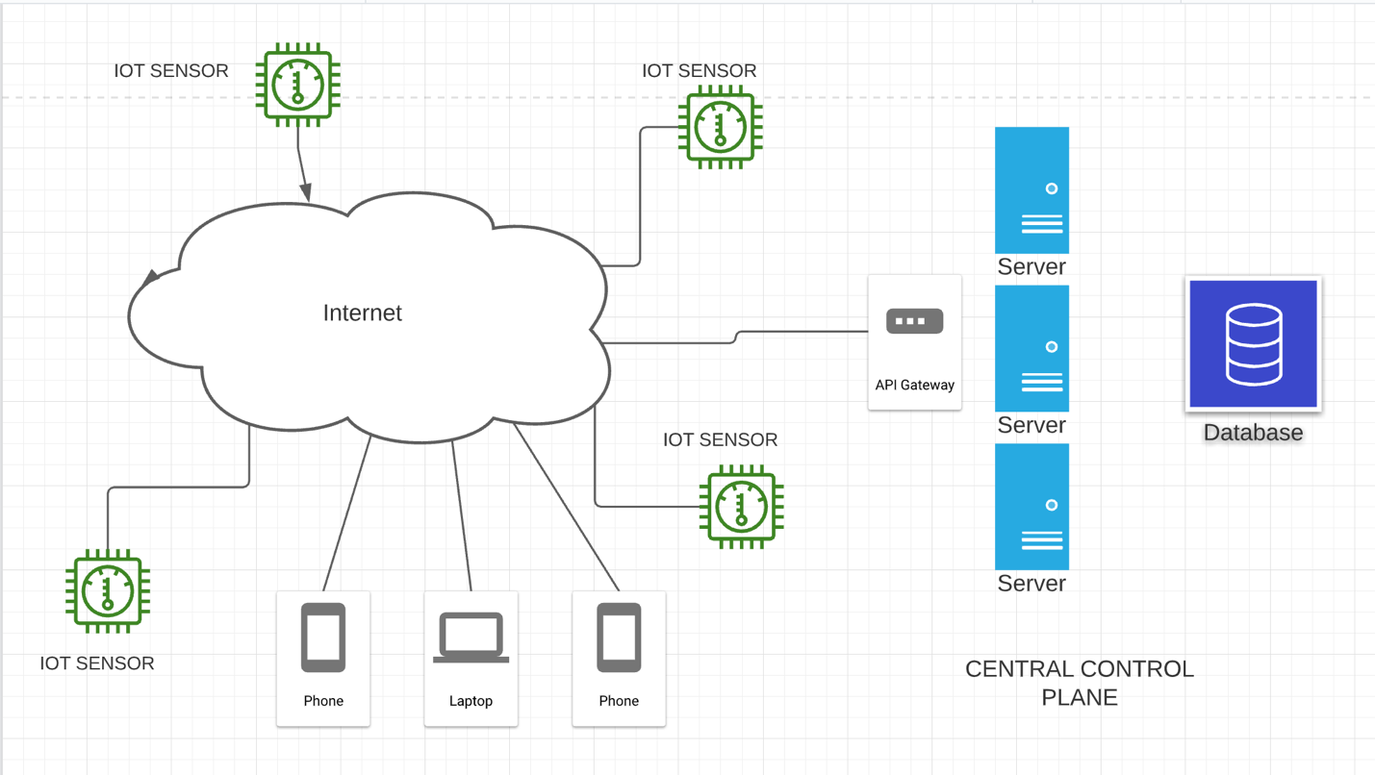

Figure: System Architecture

- The app will offer real-time weather information for multiple locations all over the world.
- The users will be able to get hourly, detailed, and extended forecasts.
- If the users are traveling, the app will give weather updates based on where they are.
- In USA, app users will be able see a live animated radar for extreme weather layers and warnings. Users in the US can also get alerts for severe weather.
- The app will offer easy-to-read weather graphs.
- The users will be able to get information about sunrise, sunset, cloud cover, etc.
- Users will be able to save multiple locations for which they need weather updates quickly.
- The app will allow the app users to share weather information on social media.
- The app will also have widgets specifically for Android and iOS devices.

Software Model

The weather application will be developed using the Agile Methodology - Scrum.

The advantages of using this model for this application are the following- Early and Predictable Delivery - By using fixed schedule Sprints of 1-4 weeks, new features are delivered quickly and frequently, with a high level of predictability. This also provides the opportunity to release or beta test the software earlier than planned if there is sufficient business value.

Predictable Costs and Schedule - Because each Sprint is a fixed duration, the cost is predictable and limited to the amount of work that can be performed in the fixed-schedule time which improves decision making about the priority of features and the need for additional iterations.

Allows for Change - While the main need is to stay focused on delivering an agreed-to subset of the product’s features during each iteration, there is an opportunity to constantly refine and reprioritize the overall product backlog. New or changed backlog items can be planned for the next iteration, providing the opportunity to introduce changes within a few weeks.
Focuses on Users - Agile commonly uses user stories with business-focused acceptance criteria to define product features. By focusing features on the needs of real users, each feature incrementally delivers value, not just an IT component. This also provides the opportunity to beta test software after each Sprint, gaining valuable feedback early in the project and providing the ability to make changes as needed.

Improves Quality - By breaking down the project into manageable units, the focus can be on high-quality development, testing, and collaboration. Also, by producing frequent builds and conducting testing and reviews during each iteration, quality is improved by finding and fixing defects quickly and identifying expectation mismatches early.

Software Implementation

Engineering Team shall follow the agile practices to implement the App System. Requirements mentioned in this doc will be translated into stories and tasks in Jira. Team will meet every week to priorities the tasks and groom stories in the backlogs.

System Requirements

Weather App system consists of the following components – Central control plane, IOT sensors and the end users. Central control plane is the hub for any communications happens in the system. It records the weathers information from the IOT sensor which it sends regularly and stores these data in a database. Each sensor sends data from a specific location and locations information is being advertised by the sensor during registration as well as with the keep alive. UI component which would be used by the end user to see weather information will be written in react and the app and it will consume the system Public API to interact with the system to fetch data over a secure connection.

So based on the above requirement, the system would be further divided into following sub systems.
- Central Control plane
- UI/Mobile App (End User consuming the weather info)
- IOT devices

Functionality
This subsection contains the requirements for the weather App system. These requirements are organized by the features or subsystem. Features are refined into use case diagrams and to sequence diagram to best capture the functional requirements of the system.

Central Control Plane

Central control plane must be the hub for any communications happens in the system
Central control plane must be available across the globe for both Sensor and user to interact with the system
Central control plane records the weather information from the IOT sensors deploy around the world
Central control plane must store sensor data in a database.
Central control plane must provide device registration for the sensor devices (IOT) deployed in the field
Central control plane should implement appropriate security measures to prevent unauthorized or insecure device management functionality.
- System must provide authentication, authorization, logging, encryption, and logging security measures.
- The system shall provide world class security mechanism at the application level that aim to prevent data being stolen or hacked.
- Central control plane must provide authentication, authorization, logging, encryption, and logging mechanism as part of security mechanism for both user and device interaction to the system
- Central control plane should be easy to deploy on cloud provider and site would be operational in a minimal time
- The system shall allow user to register and manage his/her profile.
- The system shall provide notification alert for the end user about the adverse weather conditions etc.

Provide comprehensive weather details.

The system shall display detailed weather information of the selected place or based on the user device’s GPRS

The system shall provide browsing options to see weather in details.
- The system shall display detailed weather info based on time like – last week, todays etc.

Provide Search options.

- The system shall enable user to enter the search text on the screen.

- The system shall enable user to select multiple options on the screen to search different place.

- The system shall display all the matching placed based on the search

- The system shall enable user to navigate between the search results.

Maintain customer profile.

- The system shall allow user to create profile and set their credential.

- The system shall authenticate user credentials to view the profile.

- The system shall allow user to update the profile information.

Provide personalized profile

- The system shall display both the active and completed order history in the customer profile.

The system shall display all the available components of the system to configure

- The system shall allow user to select other places to track the weather info.

- The system shall display the detailed information about the selected order.

- The system shall display the most frequently searched items by the user in the profile.

- The system shall allow user to register for newsletters and surveys in the profile.

- The system shall maintain customer email information as a required part of customer profile.

- The system shall send an account confirmation/password reset to the user through email.

Provide detailed sitemap.

- The system shall allow user to view detailed sitemap.

IOT Device.

- IOT devices are heart of the information system as they generate data for the global system deployed in multiple geo place across globe.
- IoT device must send the registration request to the central control plane with the correct auth token generated by the system admin when comes online for the first time.
- IoT device sends data about its location and to the central control plane with registration and keep alive messages
- IoT Service must send ‘keep alive’ messages to the central control plane regularly
- IoT device should send temperature sensor data to the central control plane
- IoT devices must record the weathers information from the sensor and sends regularly to the central control system
- IoT devices should handle the connection failure/transaction failures with the central control system with a reliable technique
- Usability

Graphical User Interface

- The system shall provide a uniform look and feel between all the web pages.
- The system shall provide use of icons and toolbars.

Accessibility
- The system shall provide multi language support.

Reliability & Availability

Back-end Internal Computers

- The system shall provide storage of all databases on redundant computers with automatic switchover.

- The system shall provide for replication of databases to off-site storage locations.

Performance

The product shall be based on web and must be run from a web server.

The product shall take initial load time depending on internet connection strength which also depends on the media from which the product is run.

The performance shall depend upon hardware components of the client/customer.

Security

Data Transfer

The system shall use secure sockets in all transactions that include any confidential customer information.

The system shall automatically log out all customers after a period of inactivity.

The system shall confirm all transactions with the customer’s web browser.

The system shall not leave any cookies on the customer’s computer containing the user’s password.

The system shall not leave any cookies on the customer’s computer containing any of the user’s confidential information.

Data Storage

The customer’s web browser shall never display a customer’s password. It shall always be echoed with special characters representing typed characters.

The customer’s web browser shall never display a customer’s credit card number after retrieving from the database. It shall always be shown with just the last 4 digits of the credit card number.

The system’s back-end servers shall never display a customer’s password. The customer’s password may be reset but never shown.

The system’s back-end servers shall only be accessible to authenticated administrators.

The system’s back-end databases shall be encrypted.

Supportability

Configuration Management Tool

The source code developed for this system shall be maintained in configuration management tool.

Design Constraints

Standard Development Tools

The system shall be built using a standard web page development tool that conforms to either IBM’s CUA standards or Microsoft’s GUI standards.

Web Based Product

There are no memory requirements
The computers must be equipped with web browsers such as Google Chrome, Mozilla Firefox.
The product must be stored in such a way that allows the client easy access to it.
Response time for loading the product should take no longer than five minutes.
A general knowledge of basic computer skills is required to use the product

On-line User Documentation and Help System Requirements
As the product is a weather-based app, On-line help system becomes a critical component of the system which shall provide –
It shall provide specific guidelines to a user for using the app and within the system.
To implement online user help, link and search fields shall be provided.

Purchased Components
Not Applicable

Interfaces

There are many types of interfaces as such supported by the IOT based weather app will be namely, User Interface, API, Software Interface, and Hardware Interface.
The protocol used shall be HTTPS.
The Port number used will be 443.
There shall be logical address of the system in IPv4 format.

User Interfaces
The user interface for the software shall be compatible to any browser such as Internet Explorer, Mozilla, or Netscape Navigator by which user can access to the system
The user interface shall be implemented using any tool or software package like Java Applet, MS Front Page, EJB etc.

Hardware Interfaces
Since the IoT must run over the internet, hardware shall require connecting internet.

Software Interfaces

- The app system shall communicate with the Configurator to identify all the available components to configure the IOT based sensors.
- The app shall communicate with system through API gateway to provide authentication, authorization, and load balancing to the backend servers.
- The app shall store all the required data in Timestream database (Time series database).
- The app shall end push notifications to the users in case of severe weather conditions.

Communications Interfaces

The application shall use the HTTPS protocol for communication over the internet and for the intranet communication will be through TCP/IP protocol suite.

Licensing Requirements
Not Applicable

Applicable Standards
It shall be as per the industry standard.

Data Flow Diagram

A data flow diagram (DFD) is a visual representation of the information flow through a process or system. It will be a preliminary step used to create an overview of the system that can later be elaborated. It will be used for the visualization of data processing (structured design) and show what kind of information will be input to and output from the system, where the data will come from and go to, and where the data will be stored. It will not show information about the timing of processes or information about whether processes will operate in sequence or in parallel. The following context DFD shows the high-level system processes or functions and the data sources that flow to or from them.

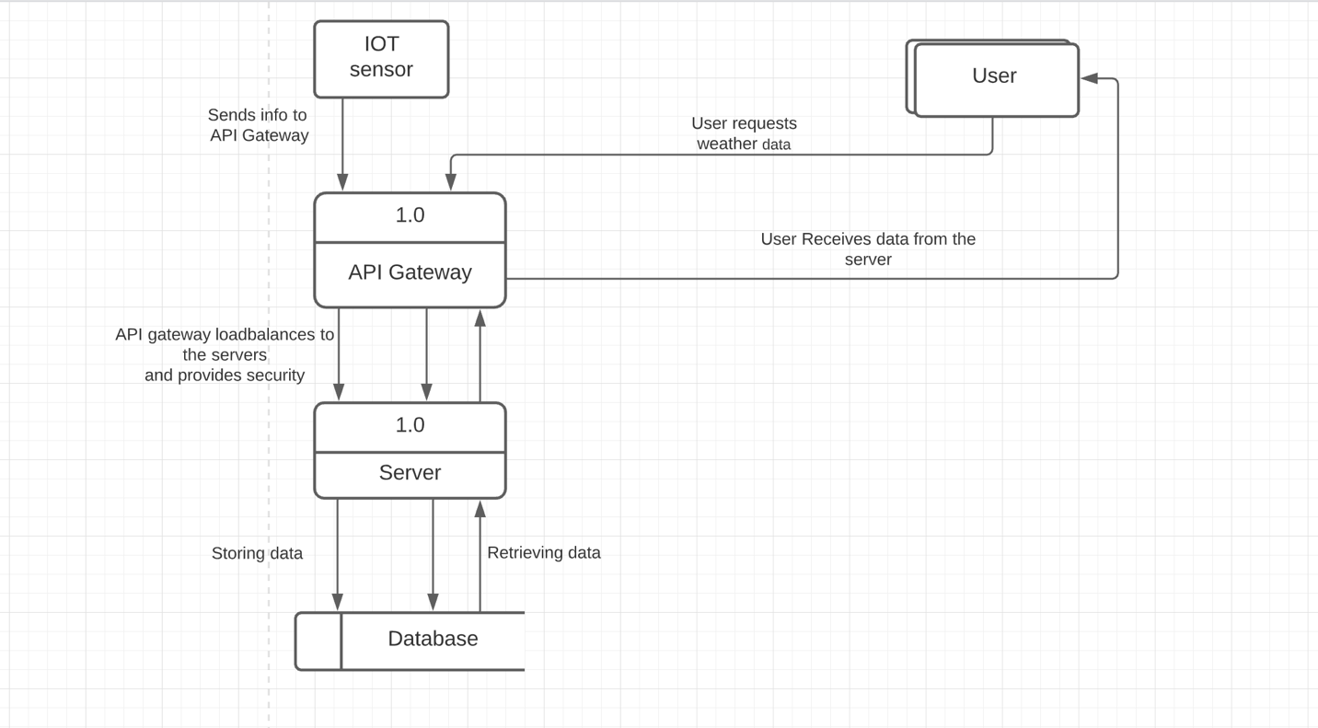
Figure: Data Flow Diagram

This product design is ready for implementation.

References:

Scheel H., Rosing M., Hove M., Fonseca M., Foldager U. (2015) The Complete Business Process Handbook

Marvel Electronics and Home (2007) Entertainment E-Store Project Software Requirement Specification

IOT Weather Reporting System - https://www.upgrad.com/blog/iot-project-ideas-topics-for-beginners/

https://www.reqview.com/doc/iso-iec-ieee-29148-srs-example

https://www.gsma.com/iot/4-iot-device-application-requirements-normative-section/

https://www.devteam.space/blog/how-to-build-a-weather-app/

